2KF8

|  |  |  |
| --- | --- | --- |
| Sequence (5’ to 3’) |  | DOI |
| GGGTTAGGGTTAGGGTTAGGGT | 223500 | 10.1021/ja807503g |

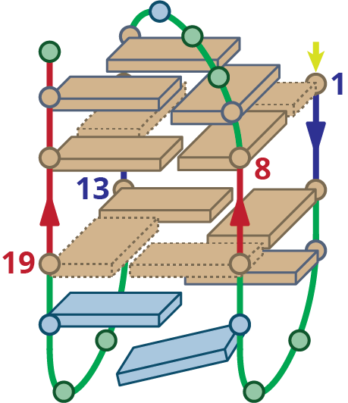

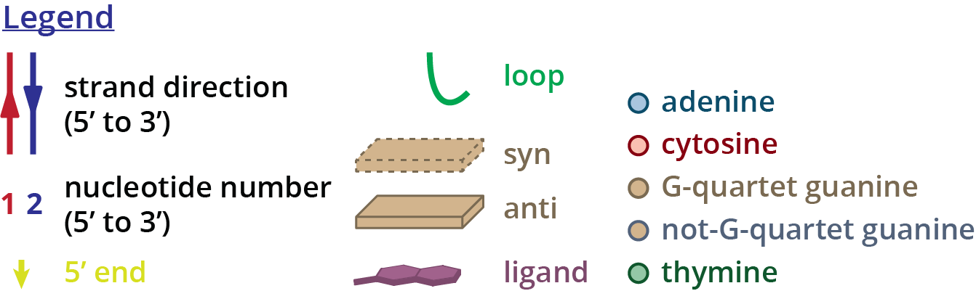

Structure diagram of 2KF8

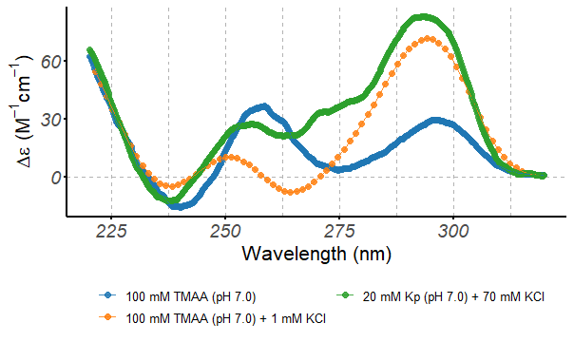

Circular dichroism spectra of the 2KF8 oligonucleotide (10 µM), acquired at 25°C in 0.4-cm path-length cuvettes

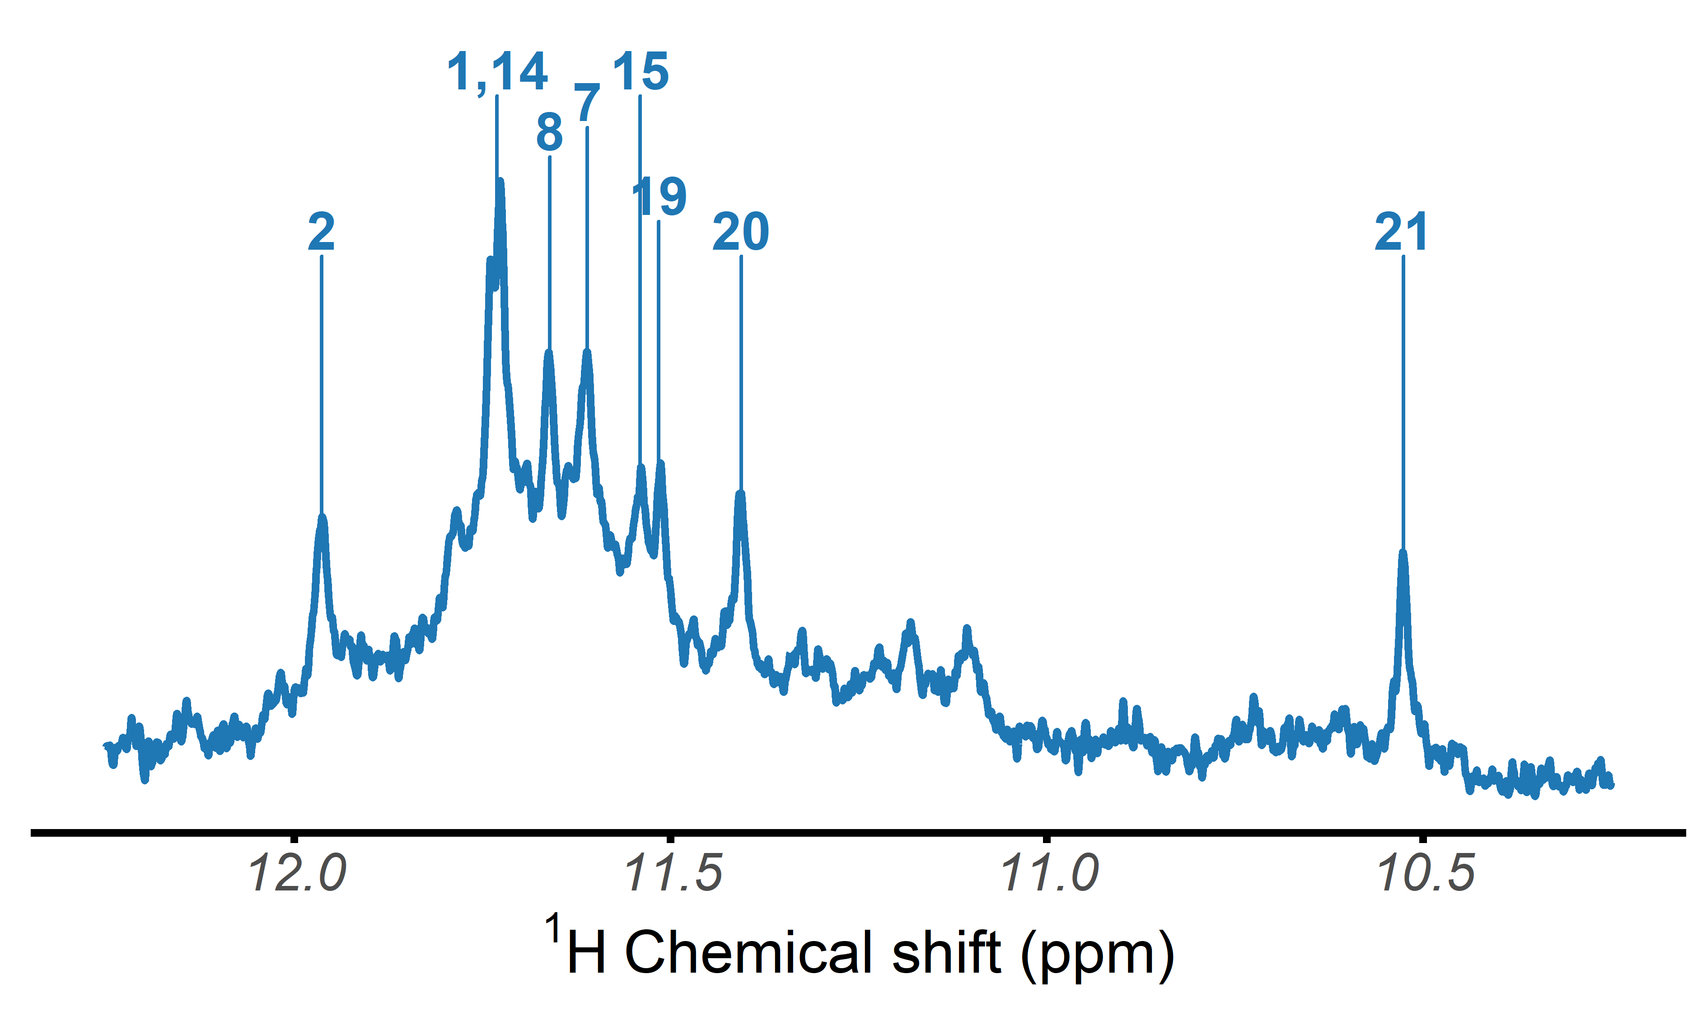

H-NMR spectrum of the 2KF8 oligonucleotide, acquired at 25°C in 100 mM TMAA (pH 7.0) + 1 mM KCl

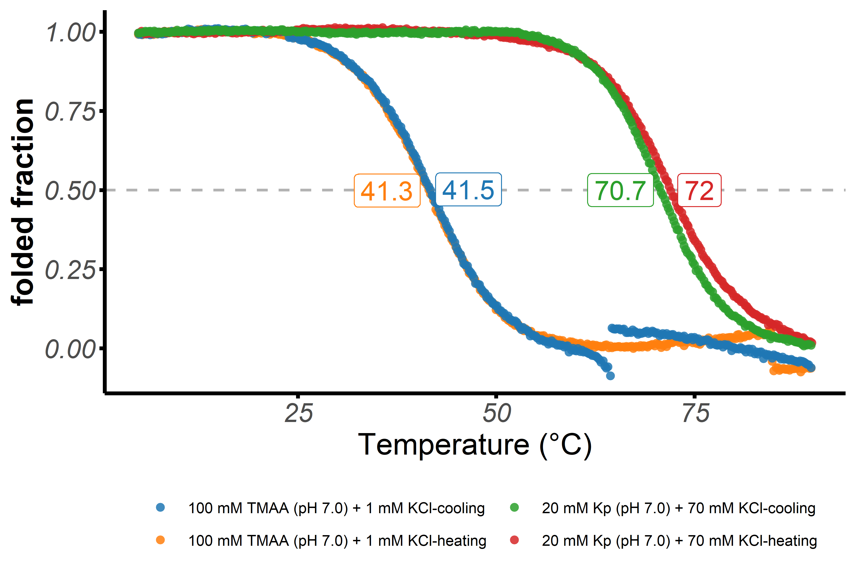

Folded fraction of the 2KF8 oligonucleotide as a function of temperature, determined by UV-melting ( = 295 nm)

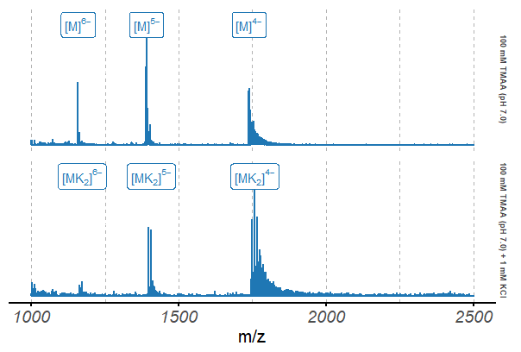

Native ESI-MS spectra of the 2KF8 oligonucleotide (10 µM)

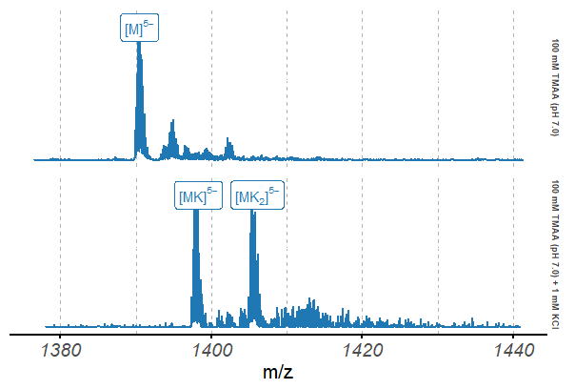

Native ESI-MS spectra of the 2KF8 oligonucleotide (10 µM), focused on the 5 charge state